*IOD Capstone Project - Ernie Lim*

**Nickel Nomad Project Document**

**Introduction:**

What is Nickel Nomad and what is its purpose?

Nickel Nomad emerged from one of the most pressing issues in the back of everyone’s minds today - *the exponential rise in the prices of goods and services, or to put it simply,* ***inflation****.*

*Bread. How much does it cost a year ago and how does that compare to a loaf of bread today?*

Attached below are some key statistics from the Australian Bureau of Statistics (ABS), which shows us that over the last 12 months, the CPI index stands at 4.1%. Some key areas of major price hikes include costs related to travel, property prices and even hospital services. At this point in time, this trend is likely to continue and to some cynics, is slated to get even worse.

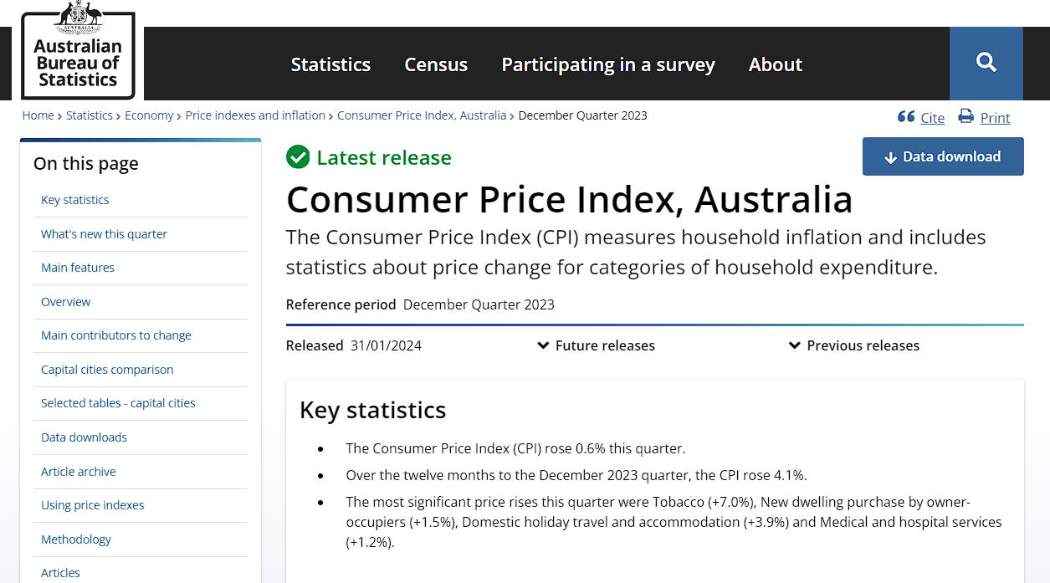

This is where Nikel Nomad comes in. The app was created to help in the fight against inflation by allowing its users to take better control of their personal finances, users are able to create budgets with an estimated cost and compare that with the actual cost of purchases made. Users of Nickel Nomad will be made more aware of their actual spending amounts and in turn better manage their personal finances as we navigate through this time.

**Industry/Domain:**

Nikel Nomad will find itself positioned in the personal finance industry. At the moment, the competitors in this industry will include ready-made budgeting excel plug-ins designed to achieve what Nikel Nomad is aiming for. These are made by personal finance influencers that sell these on social media platforms such as Instagram or Youtube.

Microsoft Excel can also be included as one of Nickel Nomad’s competitors as this app has established itself as one of the most powerful column editing software platforms, which is even used in many industries across the commercial, private and even government sectors. In comparison to Microsoft Excel and by extension the budgeting plug-ins sold by influencers, Nickel Nomad stands out by prioritizing user experience and accessibility. While Excel offers extensive features and flexibility, its performance on mobile devices can be hindered by large datasets. Nickel Nomad addresses this challenge by offering a browser-based platform, ensuring users can effortlessly manage their finances without the need for app installations or local file storage. User data is securely stored in an external server database, providing a reliable and convenient solution for users to access their financial information from any device.

**Stakeholders:**

| Stakeholders | Interest | Expectation |
| --- | --- | --- |
| Travelers | To plan and budget for all their expenses relating to their next holiday. | To cut out unnecessary travel related costs which leads to greater savings to them. |
| Students | Budget for items they need when going back to school | Able to spend within their means and not to burst their budget. |
| Hobbists | Getting into a hobby such as miniature painting, fishing is costly hence is useful to budget and plan out items to first purchase | Save on unneeded hobby items |
| Home owners | To have a weekly budget for items needed for the pantry | To stay within a certain monetary threshold to meet a financial goal such as meeting mortgage payments. |
| Medical patients | Plan the cost of treatments over time | Not exceed certain government benefits or private health insurance thresholds. |

**Product Description:**

Architecture Diagram

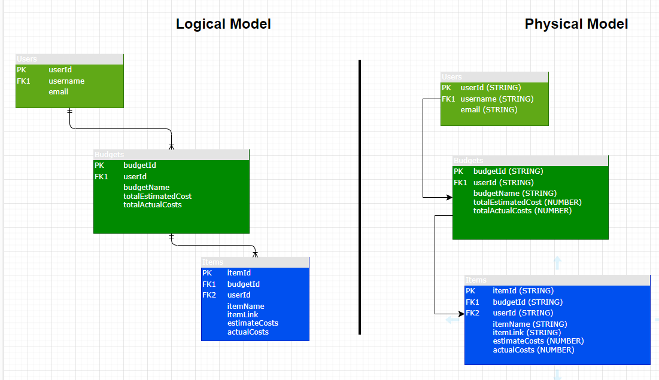

User Stories

| # | User Story Title | User Story Description | Priority | Additional Notes |
| --- | --- | --- | --- | --- |
| 1 | Create custom budget | I want to be able to create my own custom budget for a particular purpose (e.g traveling, basic household expenses). | **HIGH** |  |
| 2 | Give my budget a name | I want to be able to give my budget a name for added context. | **HIGH** |  |
| 3 | Budget Results | Budgets need to give me a total estimated and total actual cost of my intended purchases. | **HIGH** |  |
| 4 | Create a new budget item | I want to be able to add as many items related to my budget as I want and be able to delete items if I wish later on. | **HIGH** |  |
| 5 | Save my budgets | I want to save this budget for future use. | **HIGH** |  |
| 6 | Fetch my budget | To fetch my budget from a database for future edits. | **HIGH** |  |
| 7 | List of budgets | I want to have a list of budgets that I have created before for use | **MED** |  |
| 8 | User Sign Ups | I want to sign up/log in to Nickel Nomad and use the app | **LOW** |  |

## **User Flow:**

*Flow Diagram*

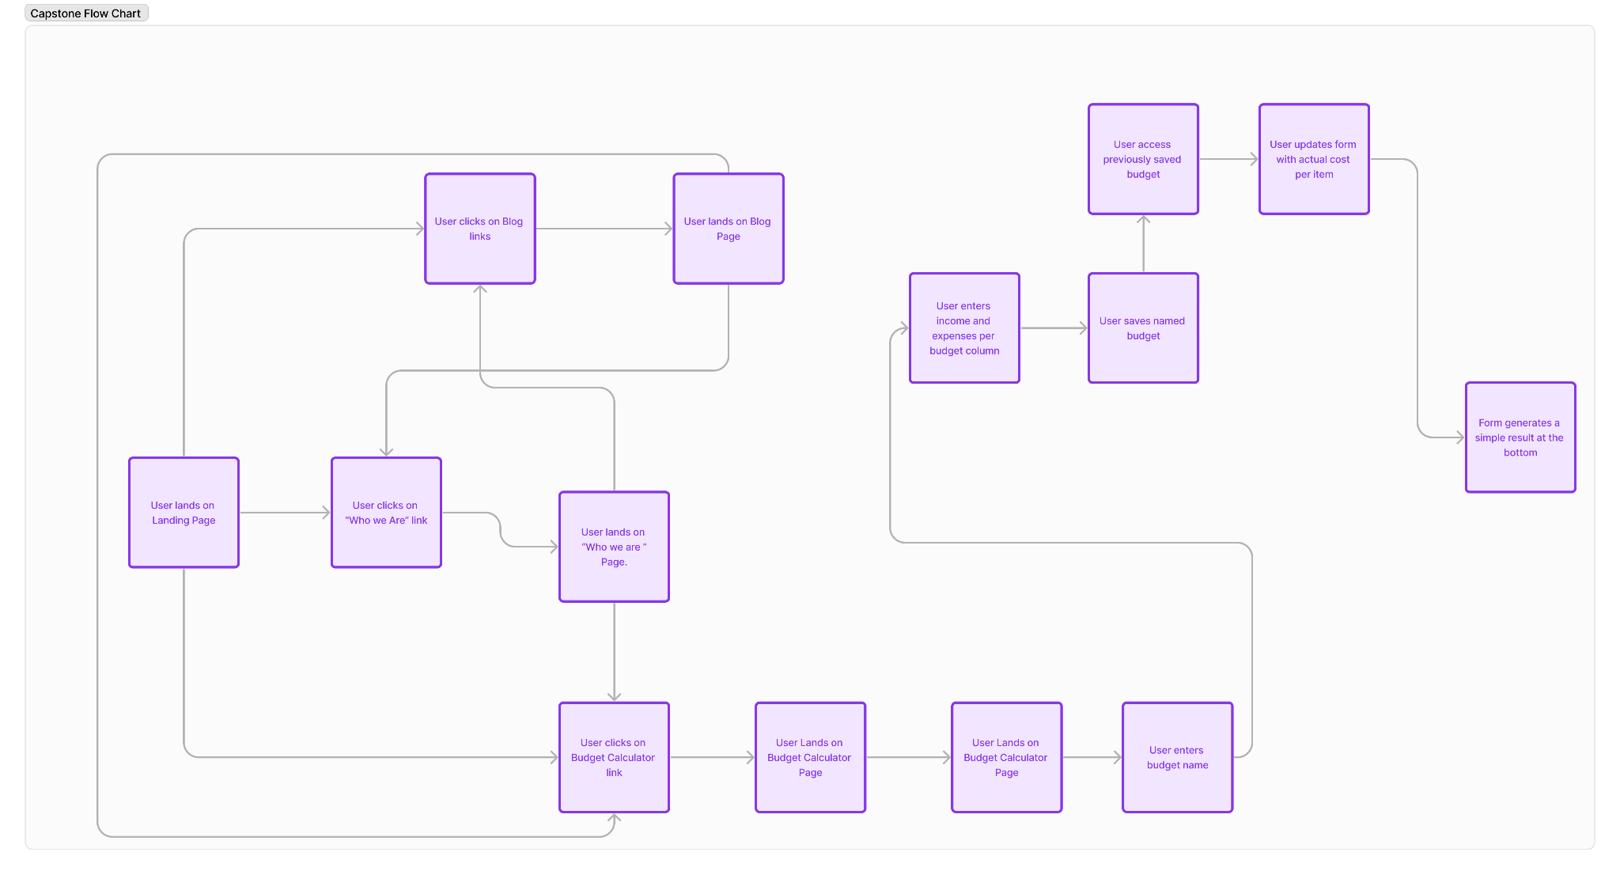

*Wireframe design*

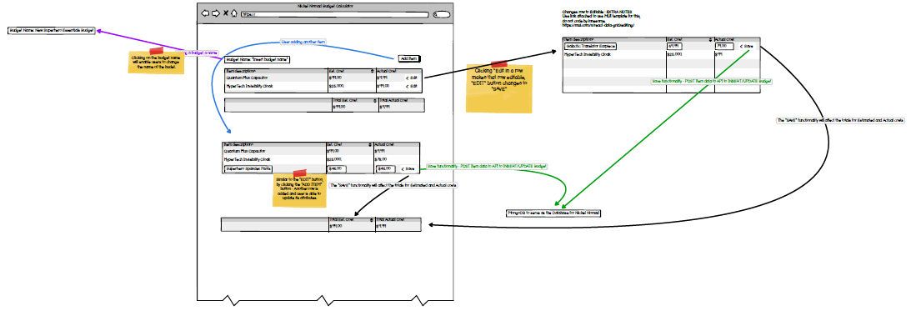

Actual PDF file included for further clarity on the above.

*Lo-Fi Figma Link:* [*https://www.figma.com/file/hD228sK6LipQqZh3ICpPA2/Capstone-project?type=design&node-id=3-12&mode=design&t=1elBiBJHi0TwSXgk-0*](https://www.figma.com/file/hD228sK6LipQqZh3ICpPA2/Capstone-project?type=design&node-id=3-12&mode=design&t=1elBiBJHi0TwSXgk-0)

**Open Questions/Out of Scope**

Features that were out of scope:

● Encryption / HTTPS

● Optimization for mobile - mobile app version of the application

**Non-Functional Requirements**

Ease of use of software

* Nickel Nomad is designed for people who are not experienced in using Excel and would prefer something without the extra bells and whistles.
* Software must be easily understood on first glance and function straightaway out of the box.

Application Response

* Application needs to be snappy and respond very quickly as this is the competitive advantage of using Nickel Nomad over Excel.

Reliability

* Since Nickel Nomad is operating in the personal finance industry, it is of the utmost importance that users can trust in the reliability of this app i.e the app functions correctly and is dependable 24/7.

**Project Planning**

*Data requirements/Collections and Backend Database Coding*

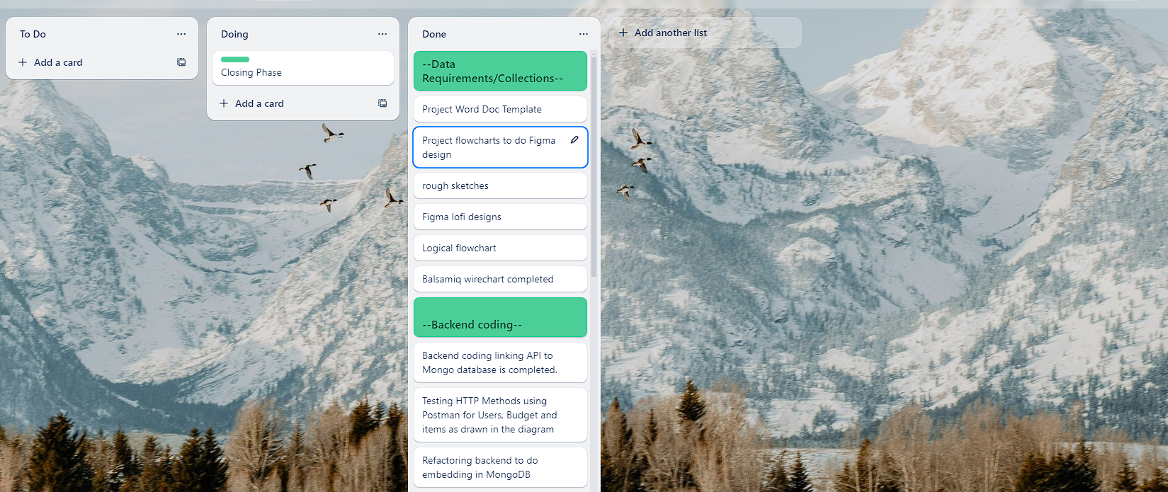

*Front -End Planning*

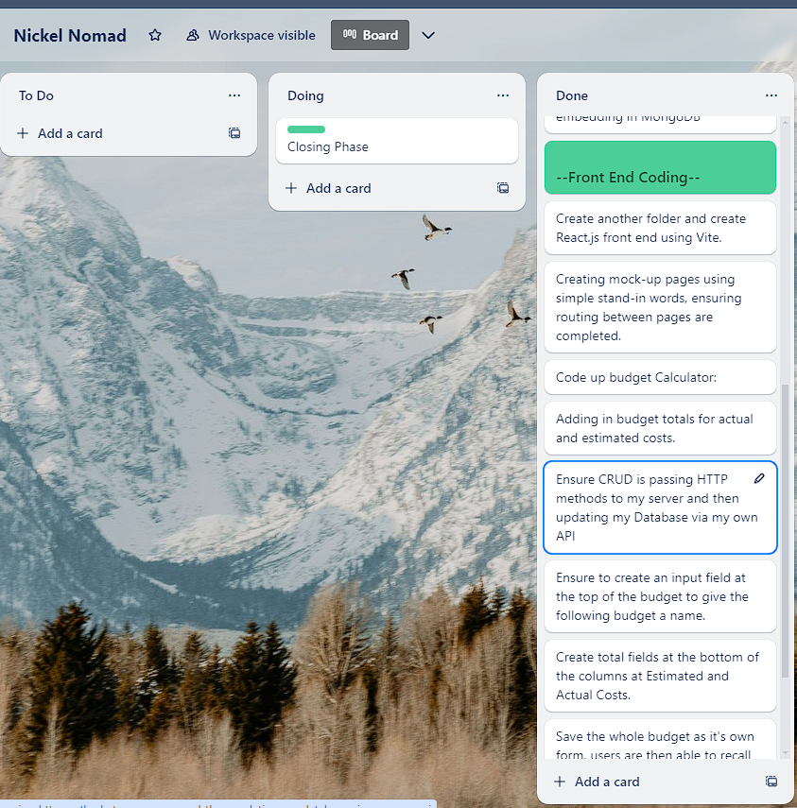

Finishing Phase:

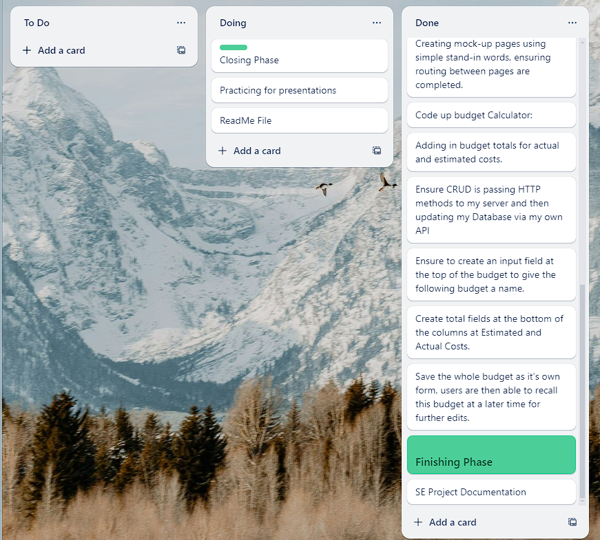

**Testing Strategy:**

Testing implemented to ensure product quality includes the following:

* Using Figma and Wireframe designs as an anchor in the coding process.
* CRUD operations are tested in Postman and requests saved to collections for easier reference and troubleshooting.
* Every component was tested functionally, errors are promptly debugged and referenced in every Github commit and pushes.
* Tested all aspects of application in the user’s POV to ensure no unexpected errors

**Implementation**:

For the scope of this capstone project, Nickel Nomad is implemented locally on local machines.

**End-to-end solution**

The application is fully functional and has met all requirements.

**References:**

*Link to repo:* [*https://github.com/Keestle/IOD-Capstone-Project-.git*](https://github.com/Keestle/IOD-Capstone-Project-.git)

*Resources used:*

* *GitHub -* [*https://github.com/*](https://github.com/)
* *MongoDB -* [*https://www.mongodb.com/*](https://www.mongodb.com/)
* *Figma -* [*https://www.figma.com/*](https://www.figma.com/)
* *Balsamiq -* [*https://balsamiq.com/*](https://balsamiq.com/)
* *Trello -* [*https://trello.com/b/T809Fe3J/nickel-nomad*](https://trello.com/b/T809Fe3J/nickel-nomad)